ASSOCIATION RULES

1)for the given data set “groceries.csv”

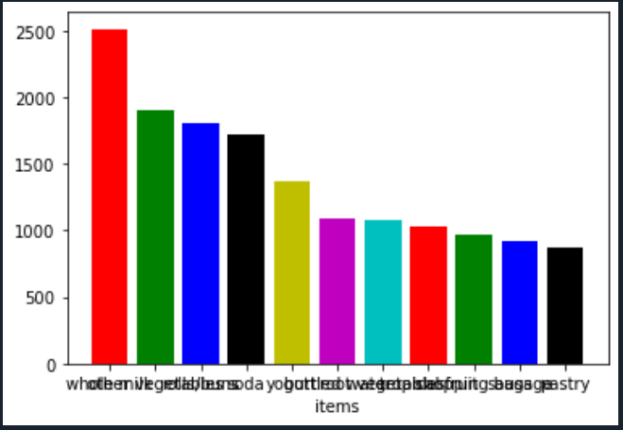

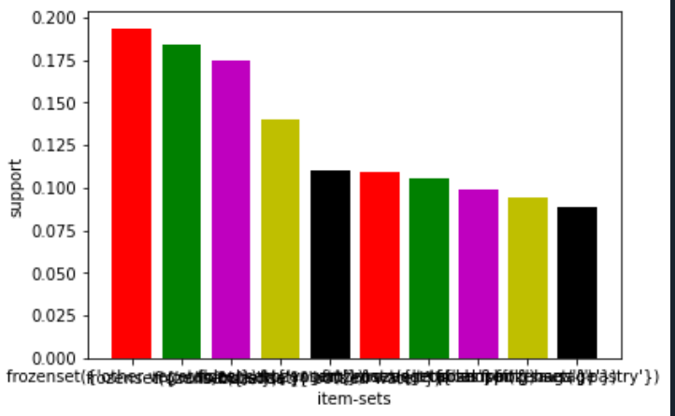

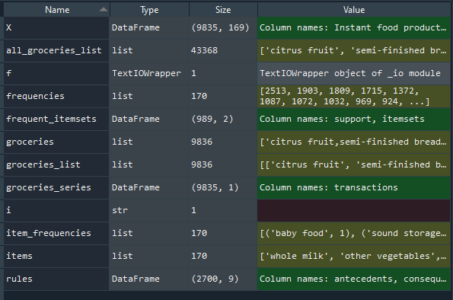

Rules:

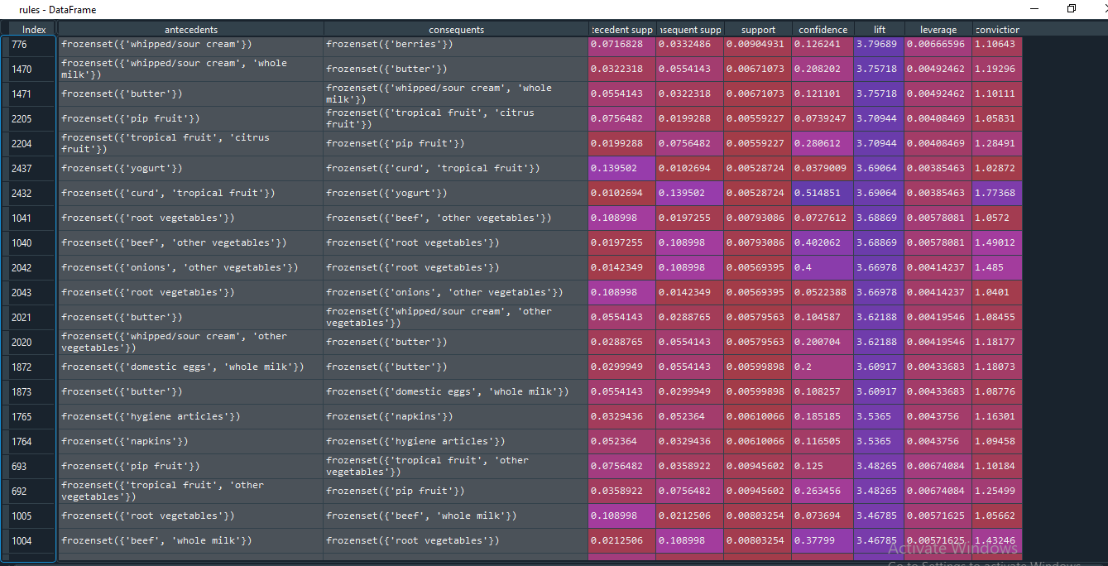

Full code:

# implementing Apriori algorithm from mlxtend

# conda install -c conda-forge mlxtend

import pandas as pd

from mlxtend.frequent_patterns import apriori,association_rules

groceries = []

# As the file is in transaction data we will be reading data directly

with open("groceries.csv") as f:

groceries = f.read()

# splitting the data into separate transactions using separator as "\n"

groceries = groceries.split("\n")

groceries_list = []

for i in groceries:

groceries_list.append(i.split(","))

all_groceries_list = []

#for i in groceries_list:

# all_groceries_list = all_groceries_list+i

all_groceries_list = [i for item in groceries_list for i in item]

from collections import Counter

item_frequencies = Counter(all_groceries_list)

# after sorting

#item_frequencies = sorted(item_frequencies.items(),key = lambda x:x[1])

item_frequencies = sorted(item_frequencies.items(),key = lambda x:x[1])

# Storing frequencies and items in separate variables

frequencies = list(reversed([i[1] for i in item_frequencies]))

items = list(reversed([i[0] for i in item_frequencies]))

# barplot of top 10

import matplotlib.pyplot as plt

plt.bar(height = frequencies[0:11],x = list(range(0,11)),color='rgbkymc');plt.xticks(list(range(0,11),),items[0:11]);plt.xlabel("items")

plt.ylabel("Count")

# Creating Data Frame for the transactions data

import pandas as pd

# Purpose of converting all list into Series object Coz to treat each list element as entire element not to separate

groceries_series = pd.DataFrame(pd.Series(groceries_list))

groceries_series = groceries_series.iloc[:9835,:] # removing the last empty transaction

groceries_series.columns = ["transactions"]

# creating a dummy columns for the each item in each transactions ... Using column names as item name

X = groceries_series['transactions'].str.join(sep='*').str.get_dummies(sep='*')

frequent_itemsets = apriori(X, min_support=0.005, max_len=3,use_colnames = True)

frequent_itemsets.shape

# Most Frequent item sets based on support

frequent_itemsets.sort_values('support',ascending = False,inplace=True)

plt.bar(x = list(range(1,11)),height = frequent_itemsets.support[1:11],color='rgmyk');plt.xticks(list(range(1,11)),frequent_itemsets.itemsets[1:11])

plt.xlabel('item-sets');plt.ylabel('support')

rules = association_rules(frequent_itemsets, metric="lift", min_threshold=1)

rules.shape

rules.head(1)

rules.sort_values('lift',ascending = False,inplace=True)

########################## To eliminate Redudancy in Rules ####################################

def to_list(i):

return (sorted(list(i)))

ma_X = rules.antecedents.apply(to_list)+rules.consequents.apply(to_list)

ma_X = ma_X.apply(sorted)

rules_sets = list(ma_X)

unique_rules_sets = [list(m) for m in set(tuple(i) for i in rules_sets)]

index_rules = []

for i in unique_rules_sets:

index_rules.append(rules_sets.index(i))

# getting rules without any redudancy

rules_no_redudancy = rules.iloc[index_rules,:]

# Sorting them with respect to list and getting top 10 rules

rules_no_redudancy.sort_values('lift',ascending=False).head(10)

2) For the given dataset “book.csv”

FuLL CODE:

# -*- coding: utf-8 -*-

"""

Created on Wed Oct 21 18:13:03 2020

@author: sunil

"""

import pandas as pd

from mlxtend.frequent_patterns import apriori,association_rules

book = []

# As the file is in transaction data we will be reading data directly

with open("book.csv") as f:

book_it = f.read()

book_it= book_it.split("\n")

book_list=[]

for i in book_it:

book_list.append(i.split(","))

all_book_list=[]

all_book_list=[i for item in book_list for i in item]

from collections import Counter

item_frequencies=Counter(all_book_list)

item_frequencies = sorted(item_frequencies.items(),key = lambda x:x[1])

frequencies = list(reversed([i[1] for i in item_frequencies]))

items = list(reversed([i[0] for i in item_frequencies]))

import matplotlib.pyplot as plt

plt.bar(height = frequencies[1:],x = list(range(0,13)),color='rgbkymc');plt.xticks(list(range(0,13),),items[1:]);plt.xlabel("items")

plt.ylabel("Count")

import pandas as pd

book_series = pd.DataFrame(pd.Series(book_list))

book_series.columns = ["transactions"]

X = book_series['transactions'].str.join(sep='*').str.get_dummies(sep='*')

frequent_itemsets = apriori(X, min_support=0.005, max_len=3,use_colnames = True)

frequent_itemsets.shape

# Most Frequent item sets based on support

frequent_itemsets.sort_values('support',ascending = False,inplace=True)

plt.bar(x = list(range(0,3)),height = frequent_itemsets.support[0:3],color='rgmyk');plt.xticks(list(range(0,3)),frequent_itemsets.itemsets[0:3])

plt.xlabel('item-sets');plt.ylabel('support')

rules = association_rules(frequent_itemsets, metric="lift", min_threshold=1)

rules.shape

rules.head(1)

rules.sort_values('lift',ascending = False,inplace=True) 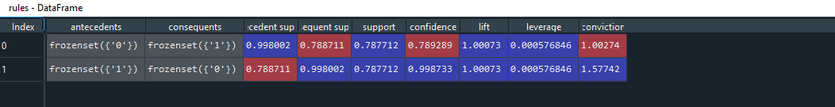

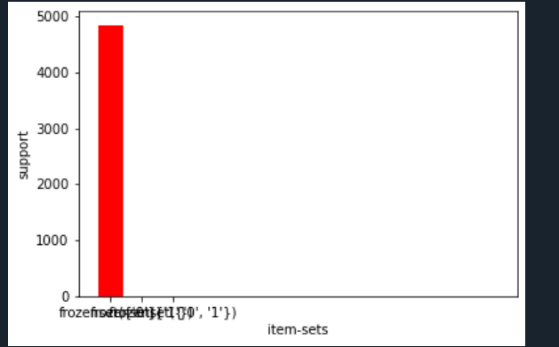

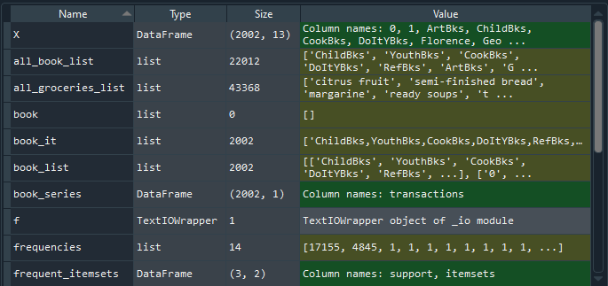

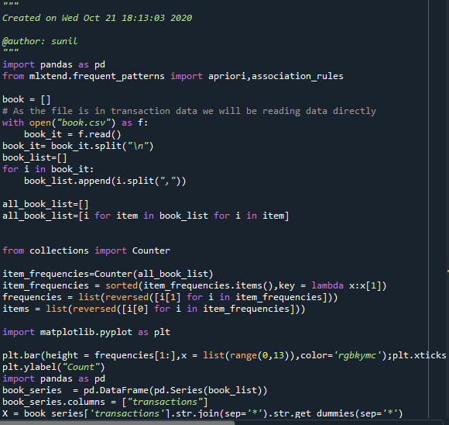

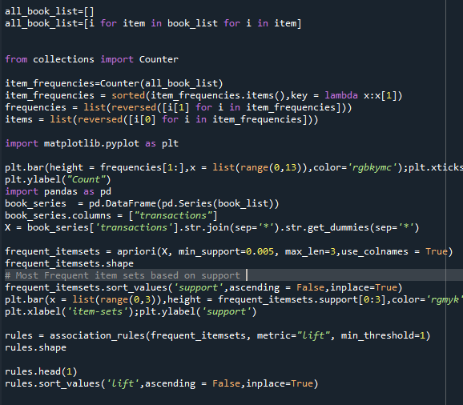

3) For the given dataset ”my_movies.csv”

FULL CODE:

# -*- coding: utf-8 -*-

"""

Created on Thu Oct 22 09:58:56 2020

@author: sunil

"""

import pandas as pd

from mlxtend.frequent_patterns import apriori,association_rules

movies=[]

with open("my_movies.csv") as f:

movies_it=f.read()

movies_it=movies_it.split("\n")

movies_list=[]

for i in movies_it:

movies_list.append(i.split(","))

all_movies_list=[]

all_movies_list=[i for item in movies_list for i in item]

from collections import Counter

item_frequencies=Counter(all_movies_list)

item_frequencies=sorted(item_frequencies.items(),key=lambda x:x[1])

frequencies = list(reversed([i[1] for i in item_frequencies]))

items = list(reversed([i[0] for i in item_frequencies]))

import matplotlib.pyplot as plt

plt.bar(height = frequencies[1:],x = list(range(0,18)),color='rgbkymc');plt.xticks(list(range(0,18),),items[1:]);plt.xlabel("items")

plt.ylabel("Count")

import pandas as pd

movies_series = pd.DataFrame(pd.Series(movies_list))

movies_series.columns = ["transactions"]

X = movies_series['transactions'].str.join(sep='*').str.get_dummies(sep='*')

frequent_itemsets = apriori(X, min_support=0.005, max_len=3,use_colnames = True)

frequent_itemsets.shape

# Most Frequent item sets based on support

frequent_itemsets.sort_values('support',ascending = False,inplace=True)

plt.bar(x = list(range(0,3)),height = frequent_itemsets.support[0:3],color='rgmyk');plt.xticks(list(range(0,3)),frequent_itemsets.itemsets[0:3])

plt.xlabel('item-sets');plt.ylabel('support')

rules = association_rules(frequent_itemsets, metric="lift", min_threshold=1)

rules.shape

rules.head(1)

rules.sort_values('lift',ascending = False,inplace=True) 